**Technical Task**

Create a reusable, mobile-first React application that displays a form with the following views:

* **Read-only mode** – during this mode you can see the details of a record pulled from an API.
* **Actions** – a list of actions. For this task, the only action is “Edit”.
* **Edit mode** – allows the user to click on fields to edit their value.
* **Edit form field mode** – editing a field’s value.

**UI guidance:**

Each view should occupy the entire application visually (see the following examples):

Details mode:

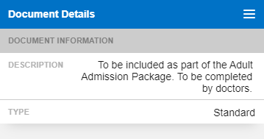

Actions mode:

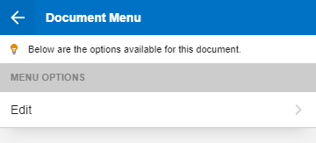

Edit mode:

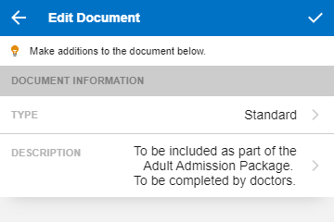

Edit form field mode:

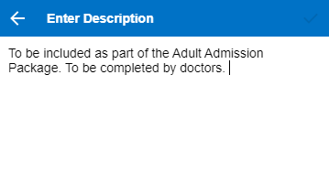

**Required form field types:**

* Select
* Select multiple
* Text area

**Additional requirements:**

* You should be able to specify mandatory form fields. The form should not allow submission if mandatory fields are not completed.
* Select and select multiple form field type options should be assumed to be populated by an API, where “display” and “value” properties are mapped to properties on the API response (i.e. “value” is mapped to “ID” and “display” to “Name”) – this should be configurable in your code.
* Submission should work and should collect the values into a sensible payload (using a mock API is fine).
* Upon submitting, the details in the form should refresh with the revised values.

**Additional information:**

* Please keep use of libraries and frameworks (other than React) to a minimum.
* Styling does not need to match the image examples, but the elements should be there in some way, i.e. a button in place of the tick or back arrow.
* There should be at least one form field for each of the required form field types listed.
* The components must be supplied with unit tests and documentation (any testing framework is fine) covering the core functionality.